HOWEST EDHUB: THE INTERACTION BETWEEN DIDACTICS, LEARNING SPACE AND TECHNOLOGY
B. Bonne, R. Dauwens, T. Verbeke
Howest (BELGIUM)

Abstract
For many years, digital competences and working with computers have more and more become an integral part of the lives of people in our society. Banks close their bank branches and work online, cars become riding computers and our health is fully monitored. Nevertheless, in education, it remains very quiet in the digital field. However, ICT can actually strengthen education and teaching, but it still runs up against barriers.
Our research intends to fill the gap between existing technological applications and education practice and thus create space for the work field and the students to explore and experiment. To that end, we do not just put the focus on learning how to work with ICT or on tool-oriented workshops, but actually on the coherence between a thoroughly elaborated didactic scope, a flexible and inspiring environment/space and approachable technological adjustments to this space and the didactics. We investigate how we can achieve learning gains by making minimal interventions in the context or the learning process. We focus on in-class differentiation and investigate how the three quoted cornerstones – learning space, didactics, ICT – can facilitate teachers in the adjustment of their existing practice.
All of this is investigated in the field, in cooperation with our work field and our students. Because, they too want to experiment more with space and ICT and verify what works in their specific context. We work together in ‘Teacher Design Teams’ in which the study department, the experts, the work field and the students work together to link space, didactics and technology as efficiently and as meaningfully as possible to one another.
In our session we want to share the current state of our research and our findings, and also introduce our course analysis instrument.
Keywords: ICT, Edtech, didactics, learning space, pre-service teacher, teacher training, Technology-Enhanced Learning.

INTRODUCTION
In our teacher training department, we noticed that our students are fearful to teach with the use of ICT and flexible or non-classic learning environments. When microteaching to their peers or when on internship, they always return to the textbooks and a fixed pattern. We noticed some barriers in the mindset of our students regarding the adaptivity of classrooms and the integration of ICT in a classroom. Even in the schools where our students do their internship, the mindset to explore these areas of didactics often lacks.
We looked in literature if these barriers often appeared and if there were other barriers we had to overcome. Barriers we came across were plenty: It could be a financial problem (lack of funds to adapt classrooms or the acquire ICT-tools), a lack of knowledge on the subject often combined with the fear to adapt ‘new’ tools, it could be the mindset of a teacher of a school and so on [1],[2], [3].
Our research intends to fill the gap between existing technological applications and education practice and thus create space for the work field and the students to explore and experiment. We intend to address two problems we are confronted with and which are also described in literature: the often-high financial threshold and the mindset of (starting) teachers and students in teacher training. We’ll look at these barriers on school level (what can schools do or engage in) and on level of the teacher (how can he or she respond to the learning space and/or the technology). What we intend to avoid in this research is to erect a high-tech future classroom which would discourage schools and teachers because this would require a financial investment they can’t make.

METHODOLOGY
To investigate how a school or teacher can easily and low-tech work at in-class differentiation we opted to erect an experimentation space within our own building, close and easily reachable for our students yet also available for teachers and schools in our city (and beyond). Future teachers can experiment in this space and have their didactical approach supported by technology and a flexible learning environment, without being assessed. In this classroom there’s a wide variety of technological tools with which they can experiment and learn.
We’re also inviting schools and teacher to come, with their pupils, to this learning space. This way they can also try and test which technology or adaptation to their class would pay off. Not by watching what we do with it, but by trying themselves. This way we want to work to lower the financial barrier that retains ICT-integration in schools. Next to this, we are also working with ‘Teacher Design Teams’ to bring the experiences of teachers into our research and into our experimentation space.
To check how our new students (first year) think about ICT and how our education at school convinces them to adapt a flexible mindset concerning ICT and new learning environments we conducted a baseline measurement in January and again in September 2018. We’ll retake these tests in their last year of their teacher training.
The same kind of test we are launching in February 2019 to teachers in our region. We want to investigate what they already know about computational thinking and how they think we can, as best as we can, support them implementing this framework. We are conducting this inquiry together with Vives University of applied sciences and ‘Provincie West-Vlaanderen’ (Province of Occidental Flanders) to maximize our range of schools and teachers.
Starting this research, we explored how pupils thought about the ‘future classroom’. In a challenge in which more than 500 pupils participated we asked them what a classroom would look like when their children are populating the classrooms. From these results we distilled some common characteristics of a future classroom (according to the pupils) and we try to add these to our experimentation space.
To meet the challenge of the mindset we are using the ‘computational thinking’ framework. In the new ‘basic objectives’ the Flemish government imposes on the schools; computational thinking is one of the key components and a literacy that has to be achieved in all courses. These new ‘basic objectives’ are new to most teacher and part of our research is to support school implementing the computational thinking framework.

Discussion

On the mindset of teachers
Little investigation has been done on how teacher integrate the ideas of computational thinking into their teaching. In their 2017 research Bower [4] states that teachers, after a workshop concerning the implementation of computational thinking in their courses, were able to swiftly adapt the basic framework, de pedagogy and the technology into their teaching practice. This could imply that you can stimulate computational thinking with only a small investment of time, if you have well suited workshops. Yet, the same research stipulates that teachers themselves notify they need more time, resources, peer mentoring and workshops [4].
Important, alongside of training, is to address the mindset of the teachers and students. Teacher who have a negative perception of the topics they must teach, influence negatively the way learners adapt the given skills and subjects [4]. This is also addressed in the study by Vongkulluksn [5]
"[…]
teachers' value beliefs also predicted how well teachers integrated technology, including how much they used technology to foster student-centered instruction and higher order tasks. These results echoed previous studies of technology integration, which have pointed to the large effect teachers' value beliefs have on classroom practice with technology".
The same conclusion you find in other research as well [6] [2] .

This is the field in which our research aims to support teachers. To that end, we do not just put the focus on learning how to work with ICT or on tool-oriented workshops, but on the coherence between a thoroughly elaborated didactic scope, a flexible and inspiring environment/space and approachable technological adjustments to this space and the didactics. We investigate how we can achieve learning gains by making minimal interventions in the context or the learning process. In our ‘quest’ to change teacher behavior, especially in the case of technology, there cannot be too much consideration of these underlying mindsets. Not least because the decisions teachers make are often based on familiar images of what they perceive as working than by frameworks and instructional design. [1] The challenge will be to find the most effective way for each individual teacher to modify/change these believes. This modification or change can be made if personal and alternate experiences (modelling) with these new technologies and environments are positive. [1] To make the experience as positive as we can, it is important to introduce teachers to all kinds of technology that satisfies their immediate needs. This should, at a minimum level, increase confidence of teachers to interact with the technology and eventually may even lead to a ‘higher level use’.

To respond to these results, we developed a didactical analyses tool that aids us mapping the needs and desires of teachers. We’ll use this tool to answer specific and individual needs of teachers. This way we can work on micro level to support them and disseminate the results of our research bottom-up into the schools to change school culture to a more adaptive approach to technology and flexible learning environments
This tool emanates from the Bloom’s taxonomy and combines this with the SAMR model. [7] To describe the current ICT practices of a teacher, we can use the Pedagogical Framework of Mobile Learning as described in Kearny & Burden [8]. Looking at the learning process supported by tablets, we are using the conversational Framework by Laurrilard [9] to examine how interactions between learners and teacher and learners mutually can be supported to make the learning process more effective. The SAMR model helps us describe the integration of ICT into the didactical approach of teachers.

Results
In following paragraphs, we summarized our preliminary results. Please note, this is ongoing research in which we don’t want to draw any final conclusions. We aim to strengthen in-class differentiation by use of technology and adjustments to the learning space. Our focus is on two barriers we try to overcome: the mindset of teachers who are not willing to use technology or change their environment and de financial implications that come with the introduction of technology. Following results are dealing with the mindset but still on a superficial scale.

Inquiries

Drawing of a future classroom by pupils
Most of the pupils drew impossible classrooms to create at this moment but not necessarily impossible in the near future. We saw teacher popping out of tablets (Holograms), foldable tablets (Samsung and others are creating them at the moment) and mobile furniture. Most important though was, and this came back in nearly every drawing of a classroom, some place to eat and drink within the classroom, preferably with comfortable seating.

Base line measurement of our first-year students
Our first-year students (18 years old) would like to use technology and are quite fond of flexible classrooms but are at the same time suspicious of flexible hours and individual trajectories for pupils. Both more negative perceptions are things they haven’t experienced in their secondary school (K-12) but will experience as high-education students. We are excited to see if these perceptions change as they themselves get more conversed with it.

Online survey on computational thinking
This will be launched in February 2019. Conclusions to be made after.

Teacher Design Teams
These will be held in 2019. Conclusion to be made after.

Pedagogical tool
We developed a pedagogical tool which will be tested coming months. The tool consists of three steps. The first steps involve the description of the challenge. Teachers are asked to write down the challenges they wish to tackle using technology and flexible space into learning goals and learning activities. In the second part the teachers can analyze, together with the researchers, how the learning goals and activities fit into Bloom’s taxonomy. Also, a part of this second step is the question how they want their lesson to be enhanced by space or technology. For this second question we are using the SAMR model.
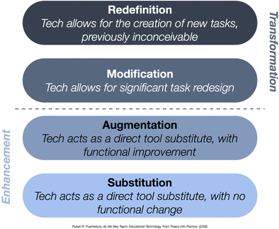
Figure 1. SAMR model.

The third step involves searching a solution for the proposed challenge either by adding technology or adapting the already used technology and/or by adapting the learning environment and/or by didactical changes. These three steps result in a model for analyses which, now, looks like this (see picture). It’s still written in Dutch and the lay-out must be improved. The purple part is step one, the red part step two and the green part step three.
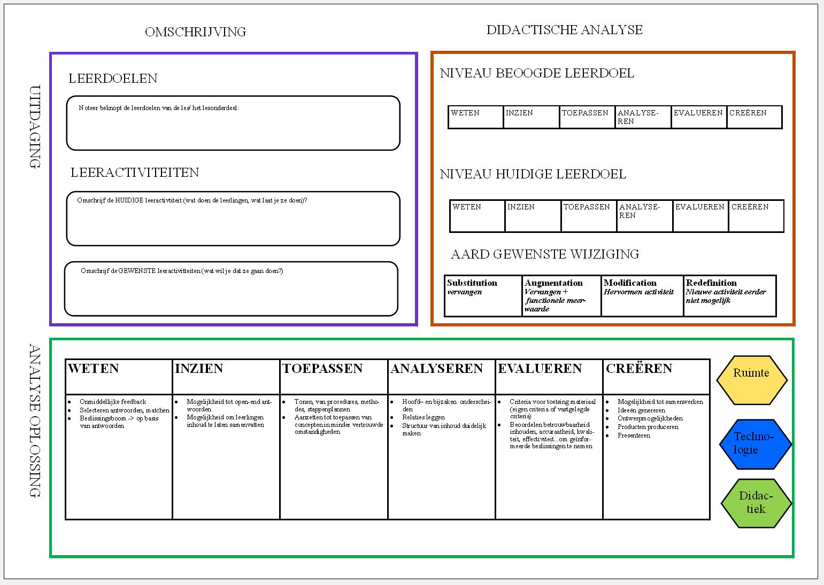
Figure 2. Didactical tool (in progress)

This tool will be tested coming months to see if it can help teachers redesign their lessons and in-class differentiation.
REFERENCES
- P.A. Ermter, “Teacher pedagogical beliefs: The final frontier in our Quest for Technology Integration?,” Educational Technology Research and Development, 53(4), pp. 25-39, 2005.
- T. Levin and R. Wadmany, “Teachers’ beliefs and practices in technology-based classrooms: A developmental view,” Journal of research on technology in education, 39(2), pp.157-181, 2006.
- A. Paniagua & D. Instance, Teachers as Designers of Learning Environments: The Importance of Innovative Pedagogies, Educational Research and Innovation, OECD Publishing, 2018.
- M. Bower, “Improving the computational thinking pedagogical capabilities of school teachers,” Australian Journal of Teacher Education, Vol. 42/3, pp. 53-72, 2017.
- A.W. Vongkulluksn, K. Xie and M.A. Bowman, "The role of value on teachers' internalization of external barriers and externalization of personal beliefs for classroom technology integration," Computers & Education, vol. 188, 70-81, 2018.
- V. Barr and C. Stephenson, “Bringing computational thinking to K-12: what is Involved and what is the role of the computer science education community?,” ACM Inroads, Vol. 2/1, pp. 48-54, 2011.
- R. Puentedura, Building transformation: An introduction to the SAMR model, 2014. Retrieved from http://www.hippasus.com/rrpweblog/archives/2014/08/22/BuildingTransformation_AnIntroductionToSAMR.pdf
- M. Kearney, “Viewing mobile learning from a pedagogical perspective,” Research in Learning Technology, vol. 20, 2012.
- D. Laurillard, Rethinking university teaching; A conversational framework for the effective use of learning technologies, Oxon, UK: Routledge Falmer, 2002.

