HOWEST EDHUB: THE INTERACTION BETWEEN DIDACTICS, LEARNING SPACE AND TECHNOLOGY
B. Bonne, R. Dauwens, T. Verbeke, Howest, Belgium

Introduction
In our teacher training department, we noticed that our students are fearful to teach with the use of ICT and flexible or non-classic learning environments. When microteaching to their peers or when on internship, teachers in training always seem to fall back on the textbooks and a fixed pattern. We noticed some barriers in the mindset of our students regarding the adaptivity of classrooms and the integration of ICT in a classroom. Even in the schools where our students do their internship, the mindset to explore these areas of didactics often falls short.
Our literature survey was aimed at indexing what barriers often appeared and if there were other barriers we had to overcome. Barriers we came across were plenty: financial difficulties (lack of funds to adapt classrooms or the acquire ICT-tools), a lack of knowledge on the subject often combined with the fear to adapt ‘new’ tools, it could be the mindset of a teacher of a school and so on.
Our research intends to fill the gap between existing technological applications and education practice and thus create room for the work field and the students to explore and experiment. We intend to address two problems we are confronted with and which are also described in literature: the often-high financial threshold and the mindset of (starting) teachers and students in teacher training. We’ll look at these barriers on school level (what can schools do or engage in) and on level of the teacher (how can he or she respond to the learning space and/or the technology). What we intend to avoid in this research is to erect a high-tech future classroom which would discourage schools and teachers because this would require a financial investment they can’t make.

Methodology
In order to facilitate our investigation on low-tech in-class differentiation strategies, we erected an experimentation space within our own building, close and easily reachable for our students yet also available for teachers and schools in our city (and beyond). In this highly flexible classroom, there’s a wide variety of technological tools with which future teachers can experiment and learn. They can experiment with different didactical strategies without being assessed.
Schools and teachers are encouraged to bring their pupils to our learning space. This way, they themselves can experiences the effects of different technologies and adaptations in order to determine which changes have the most impact. Providing this ‘test drive’ allows us to lower the financial barrier that currently holds back a lot of ICT-integration in schools. Alongside our experimentation space, we organize ‘Teacher Design Teams’ to bring the experiences of teachers into our research and into our experimentation space.
We wanted to establish a baseline on first year students’ expectations and ideas on ICT and our education at school. Specifically, we looked into how they can be persuaded to adopt a flexible mindset towards ICT and new learning environments. The baseline measurement was conducted in January, the survey was repeated in September 2018 and will be repeated in the last year of these students’ teacher training trajectories.
In February of 2019, we will expand the survey scope to teachers in our region. We want to investigate what they already know about computational thinking and what role we can take up to support them in implementing this framework. We are conducting the inquiry together with Vives University of applied sciences and ‘Provincie West-Vlaanderen’ (Province of Occidental Flanders) in order to maximize our range of schools and teachers.
Starting this research, we explored how pupils thought about the ‘future classroom’. In a challenge in which more than 500 pupils participated we asked them what a classroom would look like when their children are populating the classrooms. From these results we distilled some common characteristics of a future classroom (according to the pupils) and assessed which elements can be incorporated in our experimentation space.
To meet the challenge of the mindset we are using the ‘computational thinking’ framework. In the new ‘basic objectives’ the Flemish government imposes on the schools; computational thinking is one of the key components. Digital literacy is to be achieved in all courses. As these new ‘basic objectives’ are not familiar to most teachers,part of our research is supporting schools in implementing a framework for computational thinking in the classroom.

Discussion

On the mindset of teachers
Little investigation has been done into how teachers integrate computational thinking ideas into their teaching practices. In the 2017 study, Bower states that teachers, after a workshop concerning the implementation of computational thinking in their courses, were able to swiftly adopt the basic framework, pedagogy and technology into their teaching practice. This could imply that computational thinking strategies can be encouraged with only a small investment of time if you have well suited workshops. Yet, the same research stipulates that teachers themselves indicate they need more time, resources, peer mentoring and workshops to fully achieve their goals.
Important, alongside of training, is to address the mindset of teachers and students. Teachers who have a negative perception of the topics they teach negatively influence the way in which pupils learn given skills and subjects , influence negatively the way learners adapt the given skills and subjects. This is also addressed in the study by Vongkulluksn " […]teachers' value beliefs also predicted how well teachers integrated technology, including how much they used technology to foster student-centered instruction and higher order tasks. These results echoed previous studies of technology integration, which have pointed to the large effect teachers' value beliefs have on classroom practice with technology". Several other studies come to the same conclusion.
This is the field in which our research aims to support teachers. To that end, we do not just put the focus on learning how to work with ICT or on tool-oriented workshops, but on the coherence between a thoroughly elaborated didactic scope, a flexible and inspiring environment/space and approachable technological adjustments to this space and didactical methods. We investigate how we can achieve learning gains by making minimal interventions in the context or the learning process. In our ‘quest’ to change teacher behavior, especially in the case of technology, not too much consideration can be given to these underlying mindsets. Not in the least because the decisions teachers make are often based on familiar images of what they perceive as working than by frameworks and instructional design. Decisions teachers make are often based on their own estimation of a good teaching approach, rather than by frameworks and instructional designs. The challenge will be to find the most effective way for each individual teacher to modify/change these beliefs. This modification or change can be made if personal and alternate experiences (modelling) with these new technologies and environments are positive. To make the experience as positive as possible, it is important to introduce teachers to all kinds of technology that satisfy their immediate needs. This should, at a minimum level, increase confidence of teachers to interact with the technology and eventually may even lead to a ‘higher level use’.
To respond to these results, we developed a didactical analysis tool that aids us with mapping the needs and desires of teachers. We’ll use this tool to answer specific and individual needs of teachers. This way, we can work on a micro level to support them and disseminate the results of our research bottom-up into the schools to change school culture to a more adaptive approach to technology and flexible learning environments
This tool emanates from the Bloom’s taxonomy and combines this with the SAMR model. To describe the current ICT practices of a teacher, we can use the Pedagogical Framework of Mobile Learning as described in Kearny & Burden. Looking at the learning process supported by tablets, we are using the conversational Framework by Laurillard to examine how interactions between learners and teachers as well as between learners among themselves can be supported to make the learning process more effective. The SAMR model helps us describe the integration of ICT into the didactical approach of teachers.

Results
In following paragraphs, we summarized our preliminary results. Please note, this is ongoing research in which we don’t want to draw any final conclusions yet. We aim to strengthen in-class differentiation by use of technology and adjustments to the learning space. Our focus is on two barriers we try to overcome: the mindset of teachers who are not willing to use technology or change their environment and financial implications that come with the introduction of technology. Results regarding teachers’ mindsets are very preliminary.

Inquiries

Drawing of a future classroom by pupils
Most of the pupils drew impossible classrooms to create with current available tecnologies but not necessarily impossible in the near future. Examples include teachers popping out of tablets (Holograms), foldable tablets (Samsung and others are creating them at the moment) and mobile furniture. Most important though was, and this came back in nearly every drawing of a classroom, some place to eat and drink within the classroom, preferably with comfortable seating.

Base line measurement of our first-year students
Our first-year students (18 years old) are enthusiastic about the use of technology and are quite fond of flexible classrooms. At the same time, they are suspicious of flexible hours and individual trajectories for pupils. While in most situations, they have not yet experienced these two elements of classroom environments, they will encounter them more often during their higher education. It will be interesting to note whether their perceptions change as they themselves get more familiar with it.

Online survey on computational thinking
This will be launched in February 2019. Conclusions to be made after.

Teacher Design Teams
These will be held in 2019. Conclusion to be made after.

Pedagogical tool
We developed a pedagogical tool which will be tested in the coming months. The tool consists of three steps. The first steps involve the description of the challenge. Teachers are asked to write down the challenges they wish to tackle using technology and flexible space into learning goals and learning activities. In the second part, the teachers can analyze, together with the researchers, how the learning goals and activities fit into Bloom’s taxonomy. The second step also deals with how they want their lessons to be enhanced by space or technology. For this second question we are using the SAMR model.
The third step involves devising a solution for the proposed challenge, either by adding technology, adopting an already used technology, by implementing changes to the learning environment, by didactical changes or by any combination of these strategies. These three steps result in a model for analyses which, currently, looks like this (see picture). It’s still written in Dutch and the lay-out will be improved. The purple part is step one, the red part step two and the green part step three.
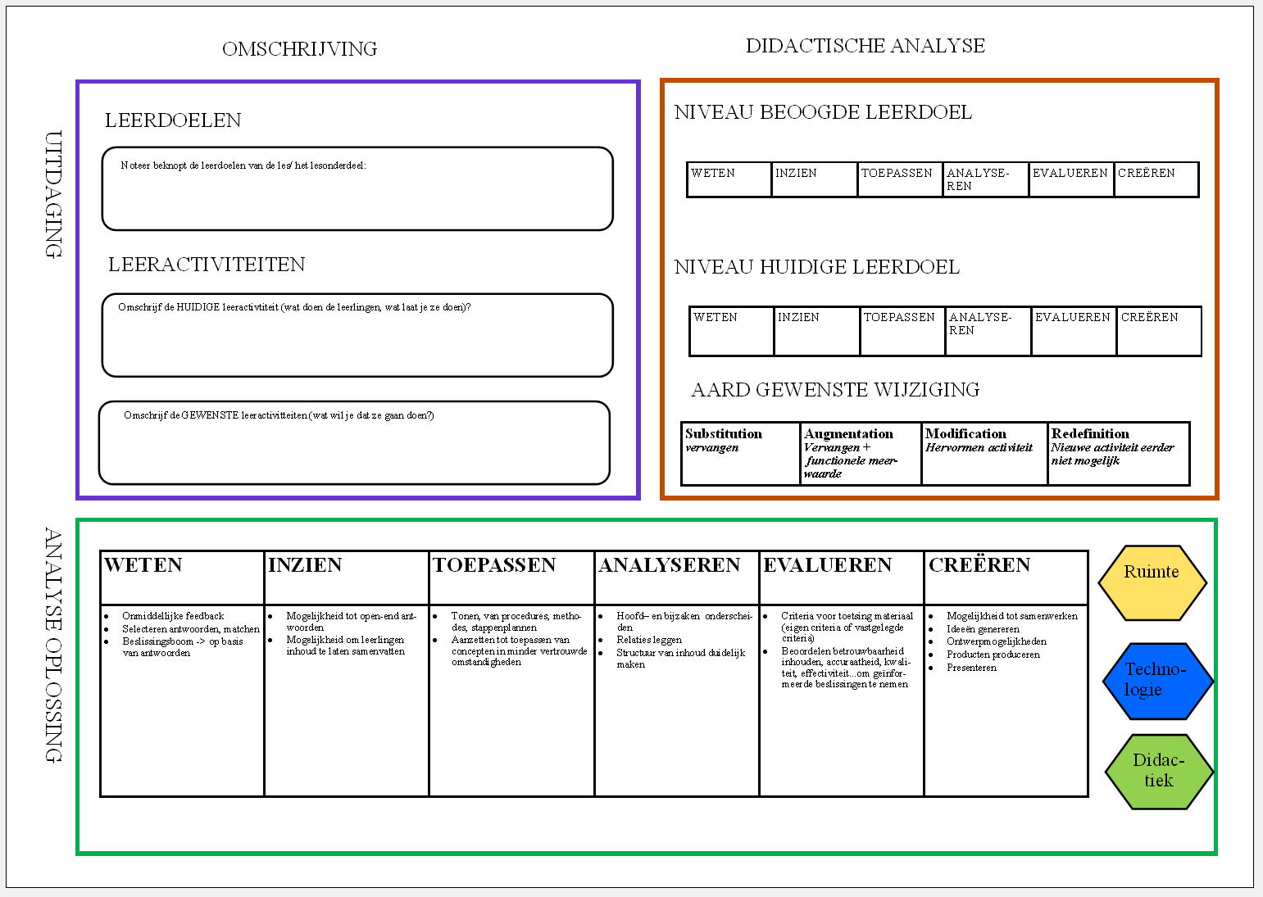
Figure 1. Didactical tool (in progress)

This tool will be tested in coming months to see if it can help teachers redesign their lessons and in-class differentiation.

References
Barr, V. & Stephenson, C. (2011). Bringing computational thinking to K-12: what is Involved and what is the role of the computer science education community?. ACM Inroads, Vol. 2/1, pp. 48-54 .
Bower, M. (2017). Improving the computational thinking pedagogical capabilities of school teachers. Australian Journal of Teacher Education, Vol. 42/3, pp. 53-72.
Ermter, P.A. (2005). Teacher pedagogical beliefs: The final frontier in our Quest for Technology Integration?. Educational Technology Research and Development, 53(4), pp. 25-39.
Kearney, M. (2012). Viewing mobile learning from a pedagogical perspective. Research in Learning Technology, vol. 20.
Laurillard, D. (2002). Rethinking university teaching; A conversational framework for the effective use of learning technologies, Oxon, UK: Routledge Falmer.
Levin, T. & Wadmany, R. (2006). Teachers’ beliefs and practices in technology-based classrooms: A developmental view. Journal of research on technology in education, 39(2), pp.157-181.
Paniagua, A. & Instance, D. (2018). Teachers as Designers of Learning Environments: The Importance of Innovative Pedagogies, Educational Research and Innovation, OECD Publishing.
Puentedura, R. (2014). Building transformation: An introduction to the SAMR model, 2014 [Blog post]. Retrieved from http://www.hippasus.com/rrpweblog/archives/2014/08/22/BuildingTransformation_AnIntroductionToSAMR.pdf
Vongkulluksn, A.W., Xie, K. & Bowman, M.A. (2018). The role of value on teachers' internalization of external barriers and externalization of personal beliefs for classroom technology integration. Computers & Education, vol. 188, 70-81.

